**TRIPS DASHBOARD REPORT**

**1. Introduction**

This document presents a comprehensive analysis of trip data, utilizing Power BI to extract meaningful insights for informed operational and strategic decision-making. The dashboard was designed to visualize key performance indicators, understand ride demand patterns, evaluate payment behaviors, analyze revenue distribution across periods, and identify high-performing geographical zones.

The primary objective of this analysis is to enhance operational efficiency, optimize resource allocation, and support data-driven marketing strategies through a detailed exploration of the data.

**2. Methodology**

The analysis was conducted using a cleaned and joined dataset, which consisted of the following tables: Trips, Trip_Details, Payment, Assembly, and Duration. These tables were integrated based on key relationships:

* Trips.faremethod → Payment.id
* Trips.loc_from and Trips.loc_to → Assembly.ID
* Trips.duration → Duration.id
* Trips.tripid → Trip_Details.tripid

Additional data preparation steps included:

* Removing missing or inconsistent values
* Creating new calculated columns for trip duration bins, revenue buckets, and trip status
* Developing DAX measures such as Total Revenue and Revenue Share by Duration
* Constructing visuals using cards, bar charts, line charts, donut charts, and filters

Power BI was used for all visualizations and analysis.

**3. Visualizations and Analysis**

**Key Performance Indicators (KPIs):**

* **Total Trips:** 983
* **Total Revenue:** 751K
* **Average Distance:** 14.39 km
* **Average Trip Duration:** 12.34 minutes

**2. Visualisations and Analysis**

**Key Metrics**

* Total Trips: 983
* Total Revenue: 751K
* Average Distance: 14.39 km
* Average Trip Duration: 12.34 minutes

**Ride Demand Over Time**The highest number of trips occurred in the 10–15 minute duration group, indicating mid-range trips are the most popular.

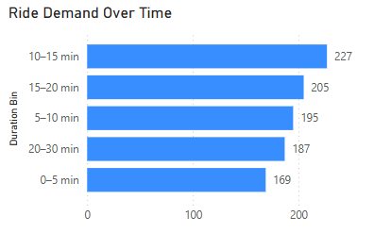

**Proportion of Revenue by Duration**Trips lasting 10–15 minutes contribute 23% of total revenue, followed by 15–20 minute trips at 21%. This emphasizes the value of mid-duration trips.

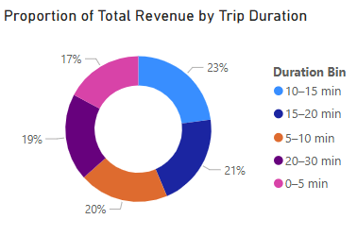

**Payment Method Analysis**Credit card was the most frequently used method, followed closely by cash and UPI, indicating strong digital adoption.

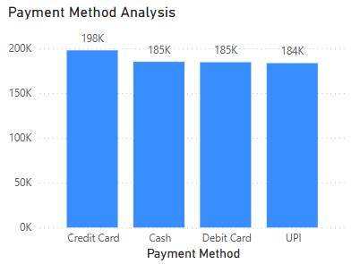

**Relationship Between Trip Hour and Revenue**Revenue is highest in the 10–15 minute group (~172K), with a gradual decline across shorter and longer durations, showing that peak revenue aligns with mid-duration demand.

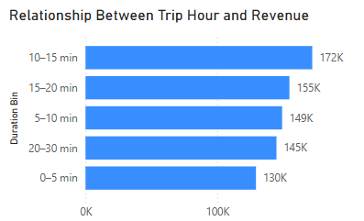

**Trip Fare by Location**Bangalore South, Yeshwanthpur, and Hebbal generated the highest fare values, suggesting dense or high-demand pickup zones.

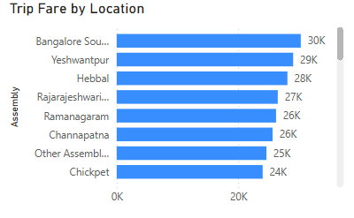

**High-Performing Zones**Zones like Ramamurthy Nagar, Bangalore South, and BTM Layout had the highest number of trips, backed by strong trip frequency and revenue figures.

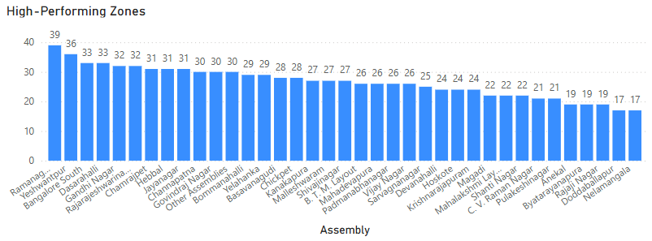

**Ride Time Periods Across Zones**Stacked bar charts indicate that most zones see a majority of trips in the 10–15 and 15–20 minute durations. Some zones also show balanced distribution across multiple durations.

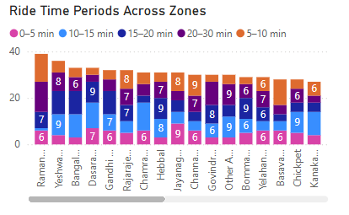

**Completed Trips After Quotes**The completion rate after receiving quotes decreases as trip duration shortens. 10–15 min trips had the highest completion percentage (~23%), while 0–5 min trips had the lowest (~17%).

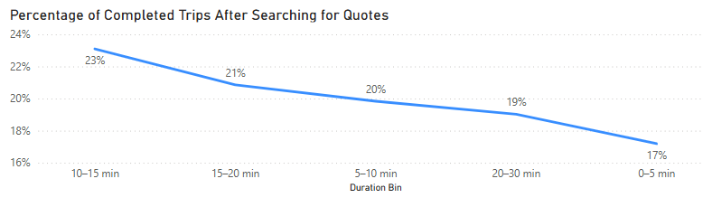

**4. Insights and Actionable Outcomes**

**Operational Efficiency Recommendations:**

* **Driver Allocation:** Increase driver presence in high-demand areas like Bangalore South and Ramamurthy Nagar to reduce wait times.
* **Trip Optimization:** Focus on optimizing routes and reducing idle time in the 10-20 minute ride range.

**Marketing and Strategic Recommendations:**

* **Incentivize Longer Rides:** Offer targeted promotions for longer rides to diversify revenue sources.
* **Payment Promotions:** Encourage digital payment methods (e.g., UPI) through cashback or discounts.
* **Geo-targeting:** Launch area-specific campaigns in zones like Hebbal and Yeshwanthpur to further increase trip volume.

**5. Conclusion**

The Power BI dashboard offers a comprehensive view of trip dynamics, from ride duration patterns to payment preferences and zone-level insights. The visualizations enable stakeholders to make informed decisions that improve service delivery and customer satisfaction.

By applying the insights from this report, the organization can streamline its operations, enhance marketing efficiency, and better serve its customers across the region.